What Makes Us Human at Work?

by John Mulholland

In most organisations money measures performance, reward, success and failure. Accountants in their counting houses count it - ironically, at great cost. Lawyers dispute over it, at even greater cost. Managers control where money is spent. Not necessarily on the right things and are often risk averse by burying their talents in the ground. Then they dig them up in January to spend before the end of the financial year so they can get more talents to bury again next year in some squirrel-like behaviour. Meanwhile their contactor has gone into liquidation due to lack of cash flow.

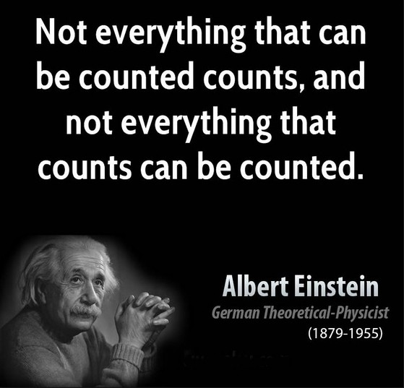

But what about the unseen currencies in your organisation? The currencies which are not easily counted or rarely quantified or measured? Such as good-will, co-operation, internal customer care, well being, compassion, flexibility, not shifting blame, taking responsibility, saying sorry, showing grace, giving credit where it is due, random acts of kindness, supporting a struggling colleague, giving undeserved favours, feeling valued and appreciated. These are some of the things which make us human at work. The things which differentiate us from machines. The things that help us get out of bed in the morning - or keep us awake at night.

We have smart phones, smart data, smart buildings and smart meters but do we have smart people? Smart leaders, and even some managers, recognise that these unseen currencies really matter. They matter far more than money. Because without them financial performance will usually be average or below average. What is an organisation? Essentially a collection of people doing stuff.

When a company buys another company they do much due diligence on the numbers (things which can be counted) but not on the unseen factors which are the key to success. I was on the Board of a company which was being sold. On the very day of completion the CEO and Financial Director were both fired. But the new owners had failed to recognise the human assets they were rejecting: the CEO was not just the CEO but also the company’s top salesman and top technical specialist. Five key clients objected and the CEO was back within three weeks working as a consultant! It took grace to return.
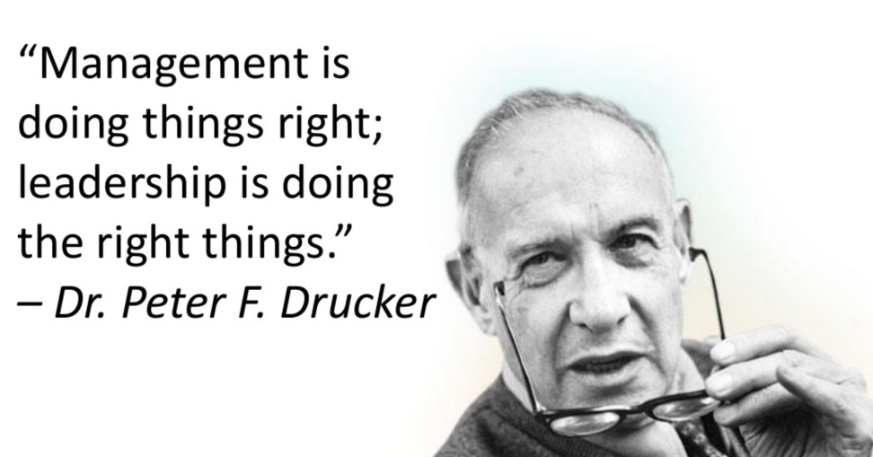

I once had a meeting with a CEO. I entered his office. He had his head in his hands and clearly was having a bad day. “Today, I have problems!”, he said. I replied “People problems?” to which he replied “Oh, is there another sort?”

We have misplaced confidence that technology and data will deliver whatever dream we are chasing. They certainly give us benefits but they haven’t yet solved climate change, global hunger, poverty, war and disease. The digital revolution promised a better standard of living, more leisure time and less stress. In fact it has delivered exactly the opposite: most people working longer hours for less pay and more stress.

What about the human dimension? Does technology make us happier or more anxious? More fulfilled? Are our relationships better? Picture four colleagues in a restaurant sat at a table in total silence, heads bowed as if having a moment of respect for a deceased colleague. But no, they are all on their smart phones and the waiter can’t get their attention to order their food. Close in proximity but miles away relationally.

Jeremy Vine on BBC Radio 2 has a slot called “What makes us human?”. He invites in a celebrity who gives a 5 minute treatise on this profound question. Then the celebrity is interviewed interspersed with relevant music like Human by Christina Perri or The Killers’: Are we human?. If you had 5 minutes on Radio 2 what would you say? “What makes us human?” is one of the most important questions we can ask ourselves. It frames our view of ourselves, others and our environment. It largely determines our values, attitudes, behaviour and actions. This, in turn, determines the unseen currencies in the workplace as described earlier.

Power-driven managers dismiss this sort of question as esoteric self indulgence. They would never stop to ponder the question as they pursue status, wealth and the next promotion but leaving in their wake co-lateral damage of failed relationships and broken colleagues. They don’t realise that most people don’t leave their jobs: they leave their bosses. When colleagues resign, they don’t ask why. A man hears what he wants to hear and disregards the rest.¹

In my last job I recruited a consultant to work on my team . On her first day I told her I wanted to be the best boss she had ever had. She looked me in the eye and said: “John, that won’t be difficult. I have had some really cr*p managers in my time!” I then realised I had set the bar too low for myself.

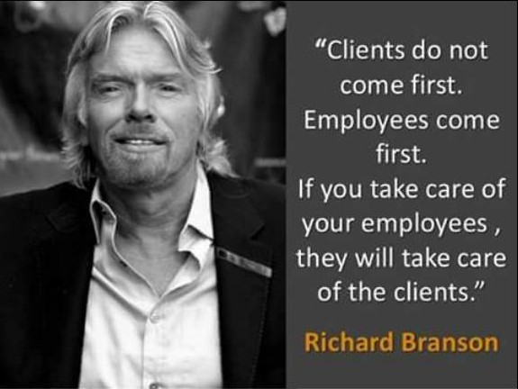

Do you ever receive emails with “do not reply” embedded in them? What does this communicate? The sender was not a human and if they were, they do not want to know. How does that make you feel? One thing I have noticed in recent years the tendency of people not responding to emails sent personally to them on a specific issue. They are the sole recipient. These people usually only communicate with you if they want something from you. But they never reply if you ask them a question. How does it feel to be ignored? How human do you feel? Do you do this yourself?

Think about a work colleague you like, respect and admire. What is it that makes you like them? What is it that makes you want to be like them?

It has been said: “To err is human but you really need a computer to foul things up”. Making errors and mistakes is a key component of learning and arriving at innovative outcomes. But making mistakes can be seen as a weakness. Therefore most people stick within their comfort zones. So innovation is usually stifled. But when mistakes are made, what happens? The first response is cover up. If that can’t be done, then blame someone else or the technology. For someone to put their hand up and say: “I made a mistake. Sorry” is not considered an option because they anticipate a bad reaction. But enlightened organisations see it as an opportunity for growth. Let’s go even further: have you ever seen a blameless person take the blame for the mistake of another? Perhaps to prevent someone being fired. That takes grace and courage. Love is wanting the very best for someone regardless of personal cost to self.

Cynics, with a limited world view, say there are two certainties in life: death and taxes. Both are popular with the Government as they represent more money to the Treasury.

Last year we remembered Shakespeare’s death in 1616. Why has the bard had such lasting appeal over 400 years? Probably because he still speaks to the human condition in us all. His plays are as relevant today as when they were written.

In one sense, our mortality defines our humanity. Shakespeare has mortality as a thread running through all his plays: All the world’s a stage and all the men and women merely players. They have their exits and their entrances.² It would have been more logical to have written “entrances and exits”. Instead Shakespeare has “Exits and entrances”. One to ponder.

When we die some family, friends and colleagues will attend our funeral (hopefully) as an act of remembrance and respect. What will you be remembered for? A glittering, or for most of us, a not-so-glittering career? How much tax we paid? How much money we made or passed on? Hardly. They will celebrate and remember what made us human. How much we loved. How much we cared. We can’t measure it but we sure can feel it.

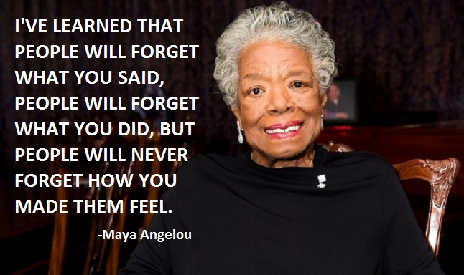

Joshua Becker in his ‘becomingminimalist’ blog poses an interesting question on gratitude.³ What if, rather than just asking, “What do I have to be thankful for?” we ask, “At the end of my life, what do I want to be thanked for?” There is little point asking this question at the end of our lives. We need to ask it now. Paradoxically, it is not what you get that matters most, but what you give. Not just for others but for ourselves. It is more blessed to give than to receive.⁴

So “What makes us human?” - probably the second most important question we can ask ourselves.

References

- Simon and Garfunkel, The Boxer
- William Shakespeare, As You Like It, Act 2, Scene 7
- www.becomingminimalist.com/be-thanked/
- Acts 20:35

