**People Aspects of ISO 50001**

**Eur Ing John Mulholland BScTech (Hons) CEng CSci MIChemE MEI**

**Director, Mulholland Energy Solutions**

**1. Introduction**

ISO 50001 is the global Energy Management System Standard, launched in June 2011 and is gaining momentum worldwide with over 10,000 organisations certified at one or more sites to January 2016. The Standard is similar in structure to the global Environmental Management Standard, ISO 14001, but focuses on energy.



An initiative called the *Energy Management Campaign* was launched in June 2016 by the Governments of Canada, Mexico and the United States, as well as the United Nationals Industrial Development Organisation (UNIDO). The campaign aims to have 50,001 global certifications to ISO 50001 by 2020.

Analysis suggests the broad implementation of ISO 50001 across the commercial and industrial sectors globally could drive cumulative energy savings of approximately 623 exajoules by 2030. This would save over $600 billion in energy costs and avoid 6,500 million tonnes of carbon emissions. (see <http://driveto50001.org>).

In the UK, certification to ISO 50001 is a route to compliance for the UK’s Energy Saving Opportunities Scheme (ESOS). In 2015/16 only 6% of organisations used this as a route for compliance. However, it is likely there will be large increase by phase 2 of ESOS in 2019.

**2. Main Elements of ISO 50001**

The main clauses of ISO 50001 fall into two main categories: energy and systems. Those familiar with management systems will be familiar with systems subjects like: documentation requirements, control of documents, internal audits, non conformities and management review. These are common to all management systems based on the Plan-Do-Check-Act continual improvement framework.

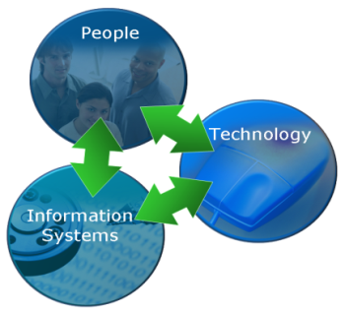

The main energy clauses fall into three main categories:

* Technical
* Information
* People

To improve energy performance all three need to be functioning in a dynamic equilibrium.

The main energy clauses cover:

|  |  |
| --- | --- |
| **Clause** | **Category** |
| **Top Management** | People |
| **Management Representative** | People |
| **Energy Policy** | Information |
| **Energy Review** | Information/Technical |
| **Energy Baseline** | Information |
| **Energy Performance/Targets/Action Plans** | Information |
| **Implementation/Operation** | Technical |
| **Competence/Training/Awareness** | People |
| **Communication** | People |
| **Operational Control** | Technical |
| **Design** | Technical |
| **Procurement** | Technical |
| **Monitoring/Measurement/Analysis** | Information |

**3. People Aspects of ISO 50001**

It could be argued that every single clause in ISO 50001 has to do with people because people have to read the Standard and people have to implement and maintain an Energy Management System (EnMS) in order to be compliant.

However, there are four clauses which focus particularly on people aspects, the areas highlighted in yellow above.

|  |  |
| --- | --- |
| **Clause** | **Title** |
| 4.2.1 | Top Management |
| 4.2.2 | Management Representative |
| 4.5.2 | Competence, training and awareness |
| 4.5.3 | Communication |

Very often energy management fails in organisations because of the lack of senior level support with little or no human or financial resources dedicated to the process. If this reflects your organisation then these clauses of ISO 50001 may provide the leverage you require.

The Standard is very specific about the role of top management in demonstrating commitment to support the EnMS. Also the role of Management Representative is specific and wide-ranging. The Standard implies an Energy Management Team is formed for larger organisations but is not explicit in this requirement.

However, the main elements of people engagement are in Clause 4.5.2 (Competence, training and awareness) and Clause 4.5.3 (Communication). These are now examined further.

**4. Competence, training and awareness (Clause 4.5.2)**

Clause 4.5.2 states:

**4.5.2 Competence, training and awareness**

The organization shall ensure that any person(s) working for or on its behalf, related to significant energy uses, are competent on the basis of appropriate education, training, skills or experience. The organization shall identify training needs associated with the control of its significant energy uses and the operation of its EnMS. The organization shall provide training or take other actions to meet these needs.

Appropriate records shall be maintained.

The organization shall ensure that any person(s) working for or on its behalf are aware of:

a) the importance of conformity with the energy policy, procedures and the requirements of the EnMS;

b) their roles, responsibilities and authorities in achieving the requirements of the EnMS;

c) the benefits of improved energy performance;

d) the impact, actual or potential, with respect to energy use and consumption, of their activities and how their activities and behaviour contribute to the achievement of energy objectives and targets, and the potential consequences of departure from specified procedures.

This clause covers two distinct types of people:

* Significant Energy Users
* All Energy Users

Both groups have to be addressed. Significant Energy Users can be those who influence significant energy use by virtue of their position (for example, a Production Manager) or by virtue of their job function (for example, an operator controlling boiler plant, refrigeration or compressed systems). The Standard makes it clear that a proper training needs analysis is required to ensure Significant Energy Users are competent on the basis of appropriate education, training, skills or experience.

Recently I conducted an ISO 50001 training needs analysis in a factory with a workforce of 40. Each individual was allocated to one of four energy intensity categories with the number of individuals shown in brackets:

* High (6)
* Medium/High (12)
* Medium (18)
* Low (4)

In this factory 6 out of 40 were evaluated as ‘High’ which is equivalent to Significant Energy Users in ISO 50001 terminology.

They received special focus in terms of training. This illustrated the Pareto (80:20) principle, i.e. 20% of the workforce control 80% of the energy and 80% control 20% of energy use.

Those not in the ‘High’ category were classified as All Energy Users. In this case it was 85% not 80% in Pareto, but near enough.

The All Energy Users group also need to be addressed. The phrase “any person(s) working for or on its behalf” includes contractors or others running plant or equipment on behalf of the organisation. The awareness requirements are specific.

So key questions to ask are:

**Significant Energy Users**

* Have all Significant Energy Users been identified by job function and/or name?
* Has a full Training Needs Analysis been conducted?
* Have Significant Energy Users been given specific training?
* Are Significant Energy Users competent?

**All Energy Users**

* Are all employees (and others) aware of:
* The importance of complying with energy policy?
* EnMS processes/requirements?
* Individual roles/responsibilities?
* Advantages of improved energy performance?
* Their own potential impact on energy consumption and energy efficiency?
* Have all training/awareness measures been documented?

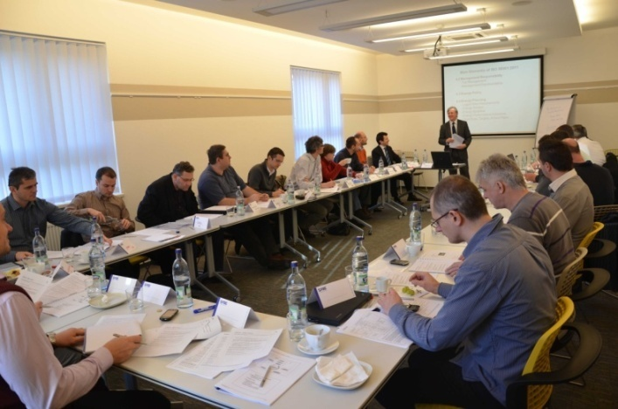

ISO 50001 training delivered by the author in Bratislava

**5. Communication (Clause 4.5.3)**

Clause 4.5.3 states:

**4.5.3 Communication**

The organization shall communicate internally with regard to its energy performance and EnMS, as appropriate to the size of the organization.

The organization shall establish and implement a process by which any person working for, or on behalf of, the organization can make comments or suggest improvements to the EnMS.

The organization shall decide whether to communicate externally about its energy policy, EnMS and energy performance, and shall document its decision. If the decision is to communicate externally, the organization shall establish and implement a method for this external communication.

There are two elements:

* Internal Communication (mandatory)
* External Communication (optional)

While External Communication is optional the decision whether or not to communicate externally needs to be documented. The issue has to be considered and the decision recorded.

The internal communication requirement has two elements:

* Communication on energy performance and the EnMS
* Mechanism for anyone to comment or suggest improvements to the EnMS

In many organisations there are existing channels which can be harnessed to meet these two requirements without much difficulty.

So key questions to ask are:

* Is energy performance and the EnMS internally communicated?
* Can all employees actively comment on/make suggestions to improve the EnMS?
* Has the organisation decided to communicate externally (and documented this decision)?
* If yes, has a plan for external communication been developed and implemented?

There is a specific requirement to have a mechanism for all employees to be able to suggest improvements to the EnMS. However, it could be argued that this should have explicitly included ideas for saving energy. This is because all employees are likely to have ideas for saving energy but not every employee will have sufficient knowledge of the EnMS to be able to make suggestions for its improvement.

**6. Benefits of ISO 50001**

The benefits of ISO 50001 can be best summarised by the 7Cs:



Many companies implementing ISO 50001 have reported significant savings in energy use which also reduces cost and carbon emissions. Because of the emphasis on continual improvement, then momentum is maintained. The EnMS engages everyone in the organisation and is an excellent platform and framework for employee engagement (see Ibstock quote below). Certification to ISO 50001 is a route to compliance with ESOS in 2019. In the supply chain it is a badge of environmental good practice, recognised globally.

Also ISO 50001 provides continuity when key staff change and because it is a continual process, energy is never off the agenda. In some organisations people solutions can be short-lived and lack momentum. But ISO 50001 provides both the framework and enabling culture to allow people solutions to thrive.

Ibstock Brick are the first brick-making company in the UK to be certified to ISO 50001.

**Ibstock Brick**

*Ibstock’s motivation for implementing ISO 50001 was to make better use of the energy we consume and achieve consistency in production processes through our people.*

*We are extremely proud of what the ISO 50001 process has achieved as it has given us a clear road map, effective communication tools, supportive external partnerships and, above all, employee involvement at all levels.*

**Michael McGowan**

**Quality, Environmental and Energy Manager**

**Ibstock Brick**

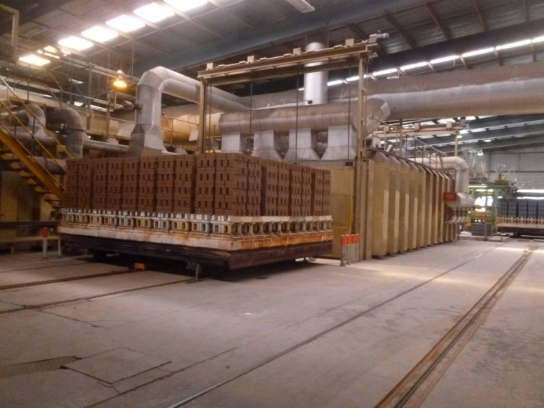 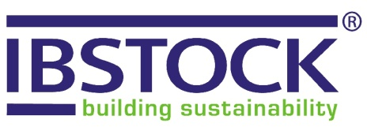

In this quotation it is noticeable how people, communication and employee engagement feature in the benefits perceived by the company.

For further details of the people dimension of Ibstock’s implementation of ISO 50001 see:

[**http://www.emexlondon.com/ibstocks-energy-management-strategy/**](http://www.emexlondon.com/ibstocks-energy-management-strategy/)

**Copies of ISO 50001 can be purchased from BSi (**[**http://shop.bsigroup.com**](http://shop.bsigroup.com)**)**

**7. Conclusion**

Any serious energy management strategy must address the human factor or it will fail. This is true irrespective of whether an organisation implements ISO 50001.

If an organisation decides to put in place an EnMS compliant with ISO 50001, then people solutions will be a key element for success. Every person in every organisation uses energy. People make things happen and people have great potential for energy waste and energy savings. People matter. Therefore people rightly are centre stage in ISO 50001.

